computer Science - C++

Lesson 26: Searches: Sequential and Binary

OBJECTIVES: The student will code a solution for a sequential search of an unordered list.

The student will code a solution for a non-recursive and/or recursive binary search of an ordered list.

ACTIVITIES/TIME: Four Days:
Day one: Presentation - 50 minutes
Worksheet - Homework
Days two - four: Lab Exercise

MATERIALS: Student Outline O.A.26.1
Worksheet W.A.26.1, Sequential Search
Answer Sheet W.A.26.1
Lab Exercise L.A.26.1, Search
Answer Sheet L.A.26.1
Lab Exercise L.A.26.2, Countwords
Answer Sheet L.A.26.2

REFERENCES: Adams, Joel, Sanford Leestma, and Larry Nyhoff. C++ An Introduction to Computing. Pages 680-682, 686-688.

Deitel, Harvey M. and Paul J. Deitel. C++ How to Program. Pages 236-239.

Savitch, Walter. Problem Solving with C++. Pages 688-699, (excellent section).

INSTRUCTOR
NOTES: A sequential search algorithm will be solved as a worksheet problem while the binary search will be tested in a program. Students can code the binary search as a non-recursive or recursive solution.

A great demonstration for the binary search algorithm is to use the yellow pages of a large phone book. Have a student pick a topic to search and proceed to binary search the yellow pages. You might consider choosing a topic in the A or Z section of the phone book, which will better illustrate a worst case scenario. Turn to the middle of the book and first check to see if you find the topic. If you do not, reapply the binary search algorithm to the appropriate half of the yellow pages. Apply this alternating split-and-check method until
the topic is found or the item does not exist. Without getting into the order of the algorithm, discuss the effect of doubling the size of the yellow pages on the number of steps to find an item. You can also comment on the value of having the yellow pages sorted by letter.

Prior to assigning this lab, print out the contents of the data file "file50.txt" sorted by the id field. The lab assignment calls for the student to search for id values as selected by the instructor. To thoroughly test the binary search routine, it is suggested you choose id values in the following locations:

1. The id value in position 0 of the array.
2. The id value at the end of the array.
3. Several other id values in the middle of the list.
4. Several id values which are not in the list:
a. An id value smaller than the first value in the list.
b. An id value which would have appeared in the middle of the list.
c. An id value larger than the last value in the list.

Students will need to have finished the store.cpp lab L.A.25.1, Store, in Lesson 25 to solve the binary search lab in Lesson 26. A function that tests the binary search algorithm has been provided to speed up the lab work. You may choose to have students type in the code or you can provide it on disk. See lab exercise L.A.26.1, Search, for details.

The second programming exercise could be challenging for your students. Here are some suggestions to modify the difficulty.

1. Provide the parseWords and validLetter functions from the answer sheet. Give the students a working program which simply prints out all the words in a text file.

2. Ask students to do a top-down analysis of the problem and determine needed functions including prototypes. This will provide some intermediate feedback about their approach to solving the problem.

A disk copy of Martin Luther King's famous "I Have a Dream" speech is provided in ap98. You are free to use a different text file if you choose.
Student Outline

Lesson 26: Searches: Sequential & Binary

INTRODUCTION: Searching for an item is a very important algorithm to a computer scientist. What makes computers tremendously valuable is their ability to store and search for information. For example, the search engines used to "surf" the Internet process incredible amounts of information. Most word processors have spell-checking abilities, which require massive amounts of searching. In this lesson, you will learn about a simple sequential search and the very effective binary search.

The key topics for this lesson are:

A. Sequential Search
B. Binary Search
C. Recursive vs. Non-recursive Algorithms

VOCABULARY: SEQUENTIAL SEARCH BINARY SEARCH

DISCUSSION: A. Sequential Search

1. Searching a linear data structure such as an array can be as simple as checking through every value until you find what you are looking for. A sequential search involves starting at the beginning of a list, sorted or not, and searching one-by-one.

2. This unsophisticated approach is appropriate for small lists or unordered lists.

3. The order of a sequential search is linear, O(N).

B. Binary Search

1. The word binary refers to the concept of two.

2. Assuming that a list was previously sorted, a value is searched for by repeating the following steps:
a. Divide the list in half
b. Check to see if the value in the middle of the list equals the value being searched for.
c. If the value is not found, then apply steps a, b, & c to the appropriate sublist.

3. As an example, suppose we have a list of 1,024 sorted values and we search for a value that happens to be stored in position 492. The list of 1,024 is split in half; the value is not found in
position 512, so we proceed to search the top half. Within the sublist from 1..512, we do another binary search sequence: split; check; and binary search again.

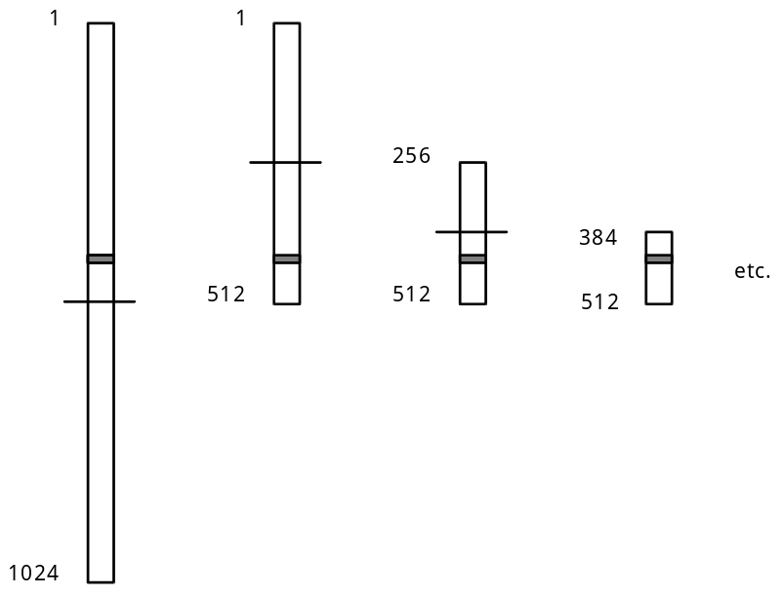

4. The speed of binary search comes from the elimination of half of the data set each time. The worst case scenario of searching a list of 1,024 elements are lists of size:

1024 --> 512 --> 256 --> 128 --> 64 --> 32 --> 16 --> 8 --> 4 --> 2 --> 1

If each arrow represents one binary search process, only ten steps are required to search a list of 1,024 numbers. The answer to log21024 is 10. If the size of the list doubled to 2,048, only one more step would be required in a binary search.

The efficiency of binary search is illustrated in this comparison of the number of entries in a list and the number of binary divisions required:

Number of Entries Number of Binary
Divisions

1,024 10
2,048 11
4,096 12
... ...
32,768 15
... ...
1,048,576 20

N log2N

5. The order of binary search is O(log2N).
C. Recursive vs. Non-recursive Algorithms

1. The binary search algorithm can be coded recursively or non-recursively. Here are some arguments for each method.

2. A non-recursive version requires less memory and fewer steps by avoiding the overhead of making recursive calls.

3. However, the recursive version is somewhat easier to understand and code. The lab assignment can be coded as either a recursive or non-recursive version of binary search.

SUMMARY/REVIEW: Searching algorithms are widely used in programs. Binary search is considered the best, assuming the list is sorted. If your course is covering the AB topics of pointers, you will learn about alternative methods of storing and searching the same data stored in file50.txt.

ASSIGNMENT: Worksheet W.A.26.1, Sequential Search
Lab Exercise L.A.26.1, Search
Lab Exercise L.A.26.2, Countwords

